**S&P 500:**

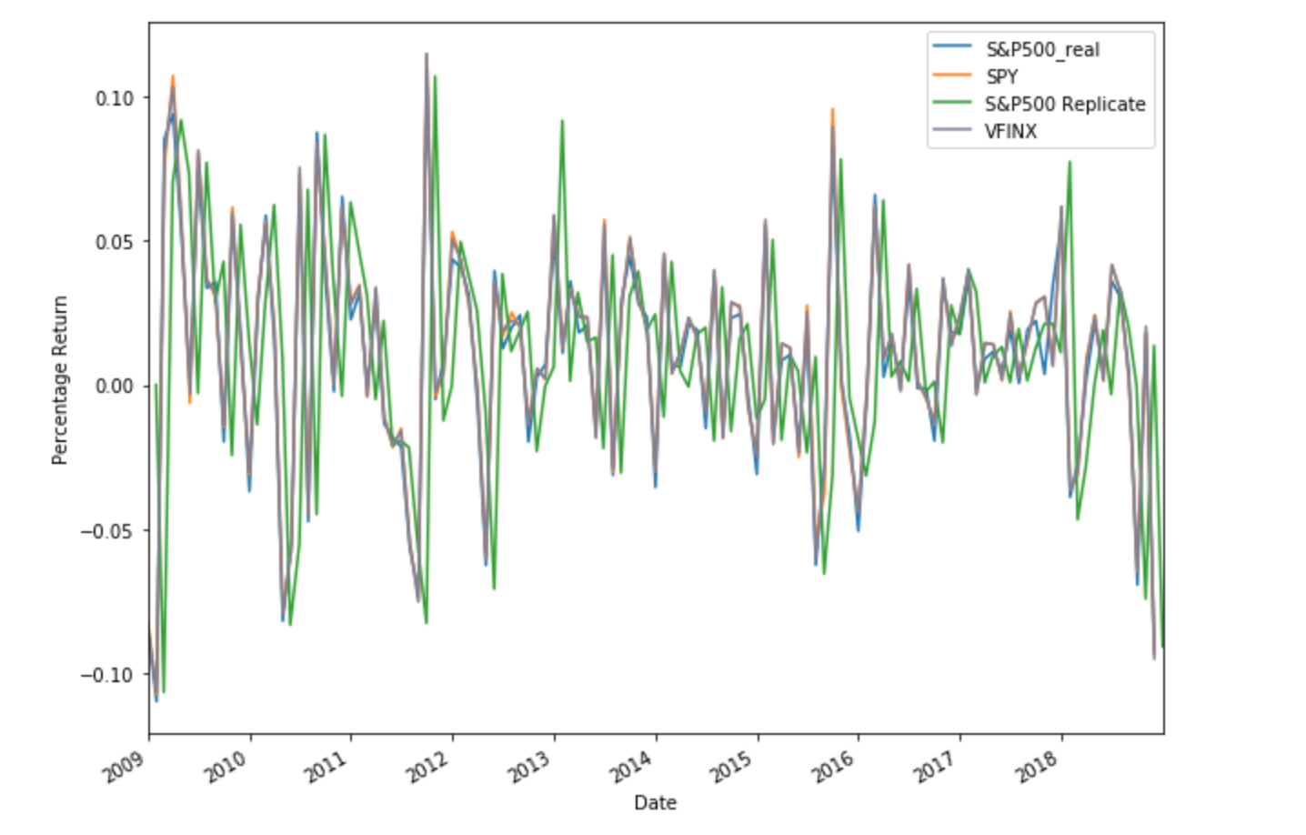

We chose the SPDR S&P500 ETF Trust (SPY) as our passive ETF. Beta for SPY is .99, making the ETF relatively lower risk than the market. It also has a low expense ratio of 0.09%, making it an ideal passive ETF. We picked Vanguard 500 Index Fund Investor Shares (VFINX) as our passive mutual fund, which has an expense ratio of 0.14% and a beta of 1.00. With such a small tracking error, VFINX actively tracks the market closely with similar proportions as the S&P 500 index.

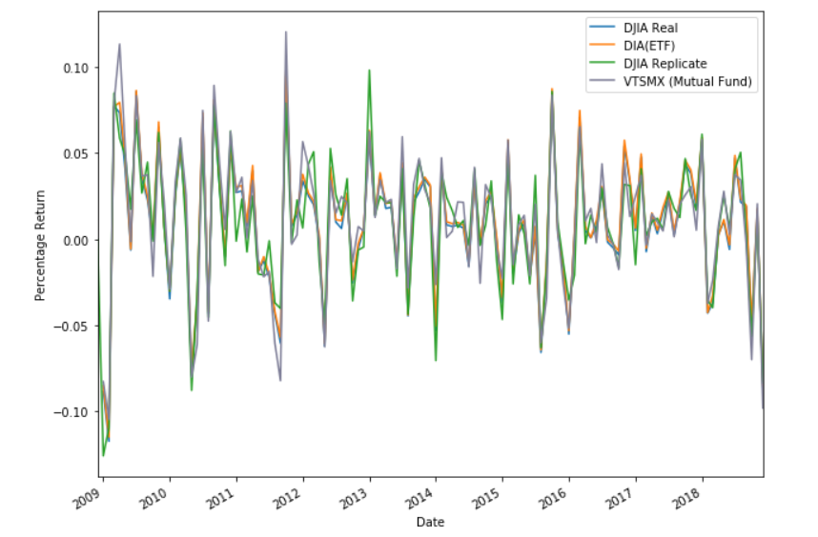**Dow Jones:**

We chose the SPDR Dow Jones Industrial Average ETF (DIA), which is the largest ETF tracking the DJIA since 1998. Its expense ratio is .17%, and has a beta of .97, making it low risk. Since DIA has been accurately tracking the DJIA for a long time, it’s theoretically less volatile. For a passive mutual fund, we chose Vanguard Total Stock Market Index Fund Investor Shares (VTSMX), which has an expense ratio of 0.14% and a beta of 1.02, meaning it is a bit higher risk when compared to the market. While it does not track the Dow perfectly, it contains several Dogs of the Dow, which makes up almost 20% of the portfolio.

|  |  |  |
| --- | --- | --- |
|  | Standard Deviation | Returns |
| Dow Jones Industrial Average | 0.1286 | 170.8% |
| S&P 500 | 0.0543 | 175.6% |

Table represents holding period of 10 years